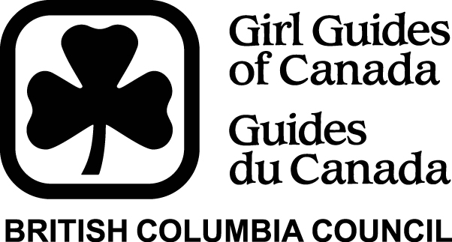  MINT COOKIES  CLASSIC COOKIES | BY SIGNING BELOW, I HEREBY AGREE  that I will pay to Girl Guides of Canada-Guides du canada –  the amount of $60.00 for each case of cookies I take from the Unit.  This amount will be paid by me as soon as possible and no later than ,

Date | Girl's Name | Number of cases taken | Parents Signature | Number of cases returned | Number of cases sold | Amount  due | Amount paid | Parent initials for amount paid | Cash/  chq? | Date Received | Date of Deposit

March 2014

